Rectifier Regulator

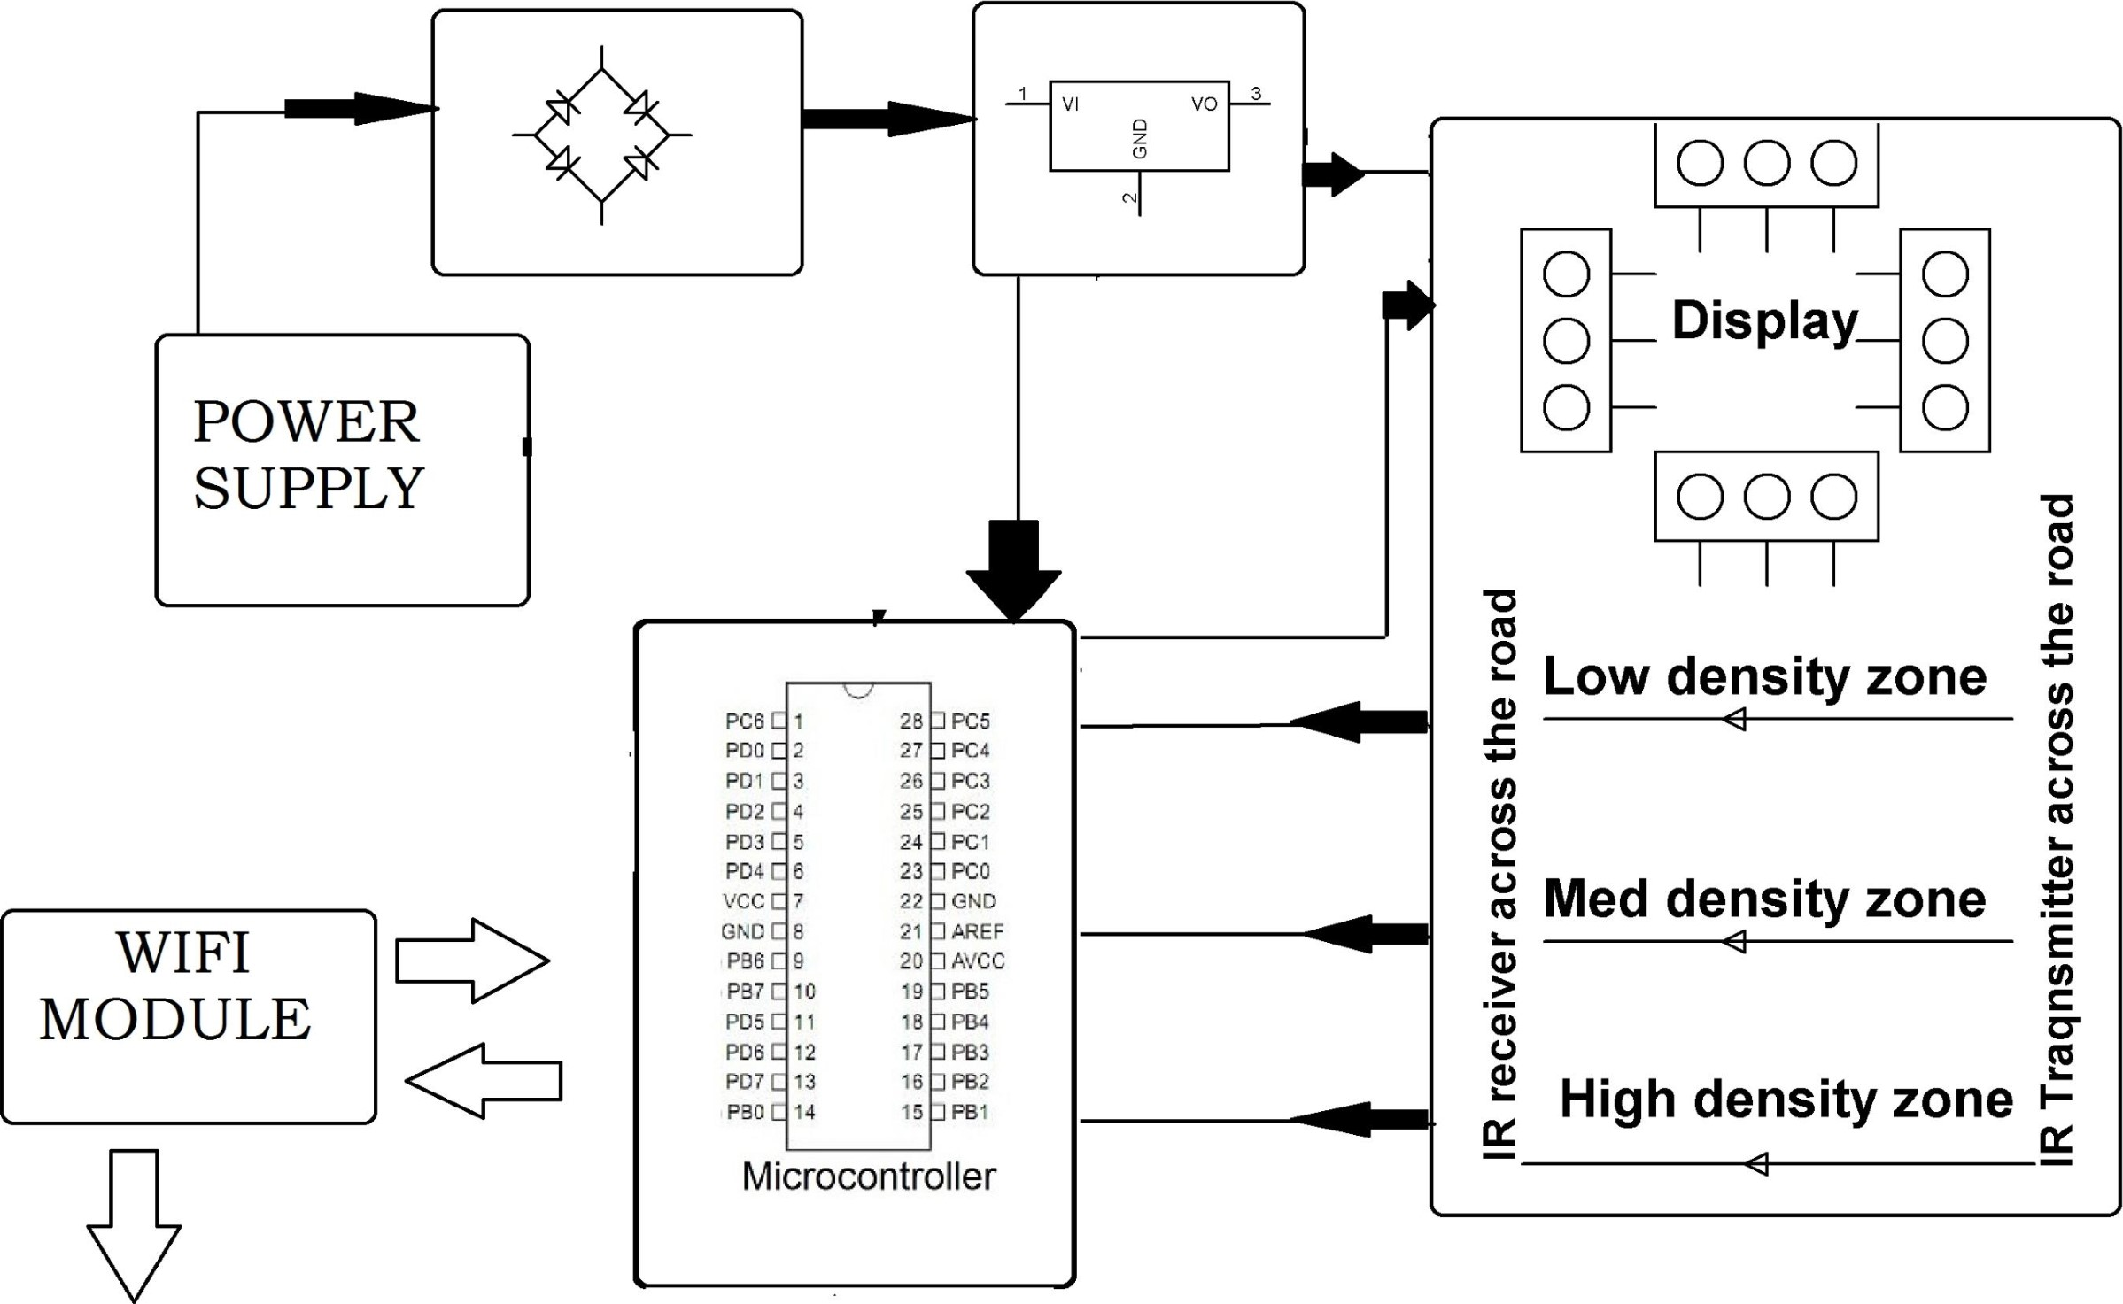

# Simple Traffic Management for IQ! Devices

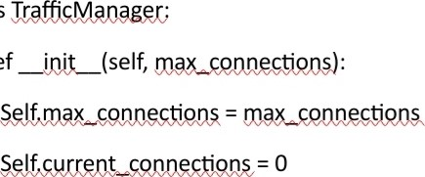Class

Def

Def

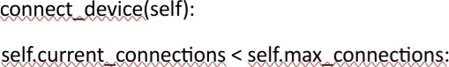If



Print("Device connected. Current connections:", 

Else:

Print("Connection limit reached. Device not connected.")

Def

If > O:



Print("Device disconnected. Current connections:", 

Else:

Print("No devices to disconnect.")

# Example usage

If 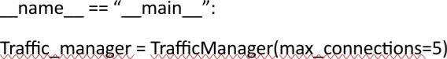

For _ in range(7):



For _ in range(3):